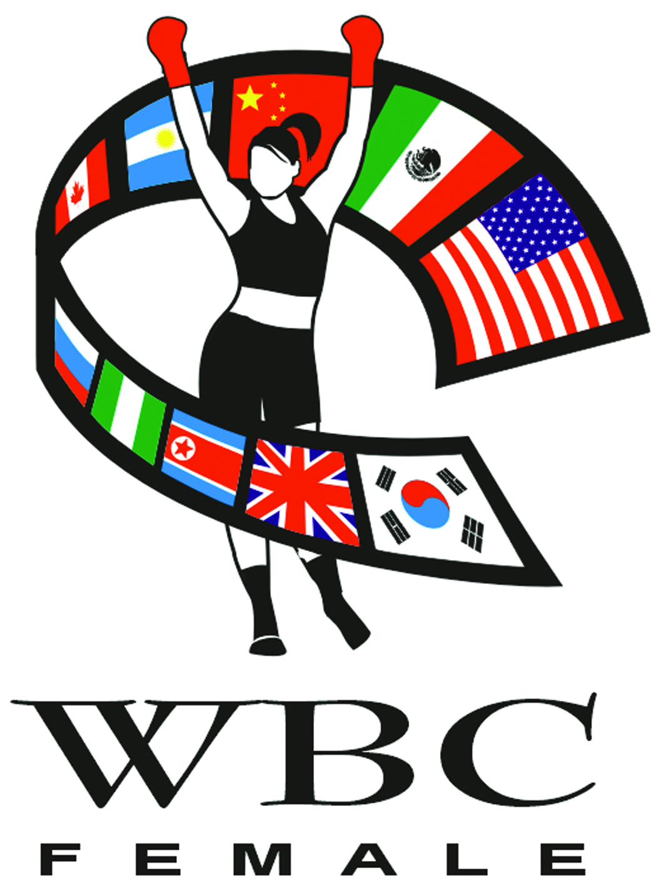 WBC FEMALE CHAMPIONSHIPS RATINGS – JANUARY 2011

HEAVYWEIGHT (168.1 + # / 76.21 + kg)

CHAMPION: VACANT (PENDING)

- IJEOMA EGBUNINE, NIGERIA
- GWENDOLYN O’NEIL, GUYANA (WIBA)
- SONYA LAMONAKIS, US
- CARLETTE EWELL, US
- MANDESA MOSES, GUYANA
- SHARON WARD, GUYANA
- YAHAIRA HERNANDEZ, DOM REP
- PAMELA LONDON, GUYANA
- DEBBIE TYSON, US
- VERONICA BLACKMAN, GUYANA
- IZABELLA TOROK, HUNGARY
- BONNIE MANN, US
- TANZEE DANIEL, US

SUPER MIDDLEWEIGHT (168 # / 76.20 kg)

CHAMPION: VACANT
CHAMPION EMERITUS – LAILA ALI, US

- NIKKI ADLER, GERMANY
- LAURA RAMSEY, US
- ZITA ZATYKO, HUNGARY
- DIANA KISS, HUNGARY
- MARIJA PEJAKOVIC, SERBIA
- PIA PORTER, GERMANY
- NOT RATED
- NOT RATED
- NOT RATED
- NOT RATED

MIDDLEWEIGHT (160# / 72.575 kg)

CHAMPION: TORI NELSON, US
WON TITLE AUGUST 6, 2011
- CHRISTINA HAMMER, GERMANY (WBO)
- TERESA PEROZZI, BERMUDA
- VASHON LIVING, US
- QUEEN TSHABALALA, SOUTH AFRICA
- LORISSA RIVAS, US
- SHELLY SEIVERT, US
- MIRIAM BRAKACHE, MORROCO
- APRIL WARD, US
- EDITH NOEMI ORELLANO, ARGENTINA
- NOT RATED

SUPER WELTERWEIGHT (154# / 69.8 kg

CHAMPION: VACANT (PENDING)
CHAMPION EMERITUS: CHRISTY MARTIN, US
ETERNAL WBC CHAMPION: JISSELLE SALANDY

- HANNA GABRIEL, COSTA RICA (WBO)
- MIKAELA LAUREN, SWEDEN
- DAKOTA STONE, US
- JENNIFER RETZKE, GERMANY (IBF)
- MARIA LINDBERG, SWEDEN (WIBF/WIBA)
- AKIMA STOCKS, US
- OLIVIA FONSECA, US
- ELIANA MARIA LENCINA, ARGENTINA
- RACHEL CLARK, US
- EVA HALASI, SERBIA
- MIHAELA DRAGON, ROMANIA
- MELISENDA PEREZ, US
- IVANA HABAZIN, CROATIA

WELTERWEIGHT (147# / 66.678 kg)

CHAMPION: CECILIA BRAEKHUS, NORWAY (WBA / WBO)
WON TITLE: MARCH 14, 2009
DEFENDED TITLE: MAY 7, 2011

- ANN SOPHIE MATHIS, FRANCE (WIBA/WIBF)
- HOLLY HOLM, US
- NONI TENGE, SOUTH AFRICA (IBF)
- JILL EMERY, US
- KUULIE KUPIHEI, US
- JESSICA BALOGUN, GERMANY
- DANIELA SMITH, NEW ZEALAND
- OLIVIA BOUDOUMA, SWITZERLAND
- ADELITA IRIZARRY, US
- GABRIELA MARCELA ZAPATA, ARGENTINA
- OXANDIA CASTILLO, DOM. REP.
- ENIS PACHECHO BARRERA, COLOMBIA
- ALEKSANDRA LOPES, US
- LISA NOEL GARLAND, US
- CINDY SERRANO, US

SUPER LIGHTWEIGHT (140# / 63.5 kg)

CHAMPION: MONICA SILVINA ACOSTA, ARGENTINA
WON TITLE: JUNE 19, 2009
DEFENDED: SEPTEMBER 9, 2011

- MYRIAM LAMARE, FRANCE (IBF)
- LAYLA MCCARTER, US
- ERIN MCGOWAN, AUSTRALIA
- MOLLY MCCONNELL, US
- FERNANDA SOLEDAD ALEGRE, ARGENTINA (WBO)
- ESTHER PHIRI, ZAMBIA (WIBA)
- CHEVELLE HALLBACK, US
- LELI LUZ FLOREZ, COLOMBIA
- MARIE RIEDERER, GERMANY
- CHRIS NAMUS, URUGUAY
- NICOLE WOODS, US
- MICHELLE LARISSA BONASSOLI, BRAZIL
- TATINA ANDERSON, US
- MIA ST JOHN, US
- CHIKA MIZUTANI, JAPAN
- KATY PENELOPE HERNANDEZ, DOM REP
- TIFFANY JUNOT, US
- DUDA YANKOVICH, YUGOSLAVIA
- LOLI MUNOZ, SPAIN
- ANITA TORTI, ITALY
- LISSETTE MEDEL, US
- JULIANA DE AGUIAR, BRAZIL
- SILVIA JIMENEZ, MEXICO
- DIANA AYALA, COLOMBIA
- KITA WATKINS, US
- DIANE SCHWACHHOFER, BELGIUM
- EVA MARCZU, HUNGARY

LIGHTWEIGHT (135# / 61.235 kg)

CHAMPION: ERICA ANABELLA FARIAS, ARGENTINA
WON TITLE: AUGUST 6, 2011
DEFENDED: DECEMBER 16, 2011

- MELISSA HERNANDEZ, PUERTO RICO (WIBA)
- ANN MARIE SACCURATO, US
- DELFINE PERSOON, BELGIUM (EBU)
- KARA RO, CANADA
- FUJIN RAIKA, JAPAN
- MARY MCGEE, US
- KIMBERLEY CONNOR, US
- ZELDA TEKIN, BELGIUM
- BROOKE MILLBROOK, US (INTERNATIONAL)
- BELINDA LARACUENTE, PR
- LUCIA MORELLI, ITALY (WIBF)
- AYANA PELLETIER, CANADA
- SARAH PUCEK, CANADA
- CYNTHIA MUNOZ, MEXICO
- CECILIA COMUNALES, URUGUAY
- PAMELA BENAVIDEZ, ARGENTINA
- NICOLE BOSS, SWITZERLAND
- MARIA ELENA MADERNA, ARGENTINA
- LAURA SAPERSTEIN, UK
- LETICIA CANDAL, SPAIN
- JENNIFER FENN-WOLFE, US
- AMY JOHNSON, CANADA
- DARYS PARDO, COLOMBIA
- ASHLEIGH CURRY, US
- SONIA MIRABELLI, ITALY

NA – MEDICAL - ROLA EL HALABI, GERMANY

SUPER FEATHERWEIGHT (130# / 58.967 kg)

CHAMPION: FRIDA WALLBERG, SWEDEN
WON TITLE: NOVEMBER 27, 2010
DEFENDED: SEPTEMBER 3, 2011

- JELENA MRDJENOVICH, CANADA
- AMANDA SERRANO, US (IBF)
- DIANA PRAZAK, AUSTRALIA (WIBA)
- RAMONA KUEHNE, GERMANY (WBO / WIBF)
- LINDSAY GARBATT, CANADA
- FUJIN RAIKA, JAPAN (OPBF)
- KINA MALPARDITA, PERU (WBA)
- JENNIFER BARBER, US
- MYRIAM CHOMAZ, FRANCE (EBU)
- RONICA JEFFREY, US (NABF)
- HYOMIN KIM, SOUTH KOREA
- OLIVIA GERULA, CANADA
- EVA WAHLSTROM, FINLAND
- JI-HYE WOO, SOUTH KOREA
- MARINA KRASHENINNIKOVA, RUSSIA
- RHONDA LUNA, US
- JENNIFER HAN, US
- DOMINGA OLIVO, US
- AGOTA ILKO, HUNGARY
- CARLA TORRES, PR
- MILENA KOLEVA, BULGARIA
- KRISTINE SHERGOLD, UK
- FATUMA ZARIKA, KENYA
- FLOAREA LIHET, ROMANIA
- KREMENA PETKOVA, BULGARIA
- LILIANA PALMERA, COLOMBIA
- ALICIA SUSANA ALEGRE, URURGUAY
- KATY KLINEFELTER, US
- ANNA DONATELLA HULTIN, SWEDEN
- JULIA ROBERT, FRANCE
- MARIA EUGINA QUIROGA, ARGENTINA
- HALANA DOS SANTOS, BRAZIL
- BRONWYN WYLIE, NEW ZEALAND
- SRIPHRAE NONGKIPAHUYUTH, THAILAND

FEATHERWEIGHT (126# / 57.153 kg)

CHAMPION: VACANT (PENDING)
INTERIM CHAMPION: MAUREEN SHEA, US
WON TITLE: DECEMBER 10, 2011
CHAMPION IN RECESS: JEANNINE GARSIDE, CANADA
CHAMPION EMERITUS - SHARON ANYOS, AUSTRALIA

- INA MENZER, GERMANY
- ALEJANDRA OLIVERAS, ARGENTINA (WB0)
- HYUN-MI CHOI, SOUTH KOREA (WBA)
- UNATHI MYEKENI, SOUTH AFRICA
- DAHIANNA SANTANA, DOM REP (IBF)
- OGLEIDIS SUAREZ, VENEZUELA
- SANDY TSAGOURAS, CANADA
- OKSANA VASILIEVA, RUSSIA
- JERI SITZES, US
- GODA DAILYDAITE, LITHUANIA
- IVONNE MUNOZ, MEXICO
- STACEY REILE, US
- ELA NUNEZ, US
- IRMA BALIJAGIC, BOSNIA & HERZEGOVINA
- THADDINE JOHNSON, US
- CAPUCINE PAUCHET, FRANCE
- KIRA SCHNUERER, GERMANY
- JACKIE TRIVILINO, US
- ANTONINA AYALA VAZQUEZ, PARAGUAY
- NYDIA FELICIANO, US
- NOHIME DENNISSON, US
- BETIANA PATRICIA VINAS, ARGENTINA
- ALYS SANCHEZ, VENEZUELA
- DAYANA CORDERO, COLOMBIA
- YOLIS MARRUGO FRANCO, COLOMBIA
- GAELLE AMAND, FRANCE
- RUKIA NASARITE, KENYA
- JUDY WAGUTHII, KENYA
- JANE KAVULANI, KENYA

SUPER BANTAMWEIGHT (122# / 55.338 kg)

CHAMPION: ALICIA ASHLEY, US
WON TITLE: JULY 23, 2011
INTERIM CHAMPION: JACKIE NAVA, MEXICO (WBA)
WON TITLE JANUARY 30, 2010
DEFENDED TITLE: JANUARY 29, 2011
EMERITUS CHAMPION: MARCELA ACUNA, ARGENTINA

- ADA VELEZ, US (IBF)
- ANA JULATON, PHILIPPINES/US (WBO)
- LISA BROWN, CANADA (WIBA)
- ELINA TISSEN, GERMANY
- MARIA ELENA VILLALOBOS, MEXICO (SILVER)
- CHANTTALL MARTINEZ, PANAMA
- YESICA PATRICIA MARCOS, ARGENTINA
- CLAUDIA ANDREA LOPEZ, ARGENTINA (LATINO)
- JENNA SHIVER, US
- TENKU TSUBATA, JAPAN
- TERRI LYNN CRUZ, US
- MELINDA COOPER, US
- LAURA SERRANO, MEXICO
- MARYLIN HERNANDEZ, DOM REP (WIBF)
- CHRISTINA RUIZ, US
- SIMONE DA SILVA DUARTE, BRAZIL
- JENNIFER SALINAS, US
- DANIELA ROMINA BERMUDEZ, ARGENTINA
- IVONNE ANAHI CORDOBA, ARGENTINA
- SOLEDAD MATTHYSSE, ARGENTINA
- MAGALI RODRIQUEZ, MEXICO
- RIYO TOGO, JAPAN
- SAINUMDOI PITAKLO-NGEN, THAILAND (ABCO)
- ROCIO CASTILLO, MEXICO
- PAULINA CARDONA, COLOMBIA
- ROXANA VIRGINIA BARON, ARGENTINA
- MARIA DEL CARMEN POTENZA, ARGENTINA
- MARIA ANDREA MIRANDA, COLOMBIA
- NATHALIE FORGET, CANADA
- BRITTANY CRUZ, US
- FREDEE GONZALEZ, MEXICO
- HELEN JOSEPH, NIGERIA

BANTAMWEIGHT (118# / 53.524 kg)

CHAMPION: USANAKORN KOKIETGYM, THAILAND
WON TITLE: OCTOBER 5, 2009
DEFENDED: OCTOBER 4, 2011
DIAMOND CHAMPION: ANA MARIA TORRES, MEXICO

- ZULINA MUNOZ, MEXICO (YOUTH / SILVER)
- KALIESHA WEST, US (WBO)
- HAGAR SHMOULEFELD FINER, ISRAEL (WIBF)
- YAZMIN RIVAS, MEXICO (IBF)
- JANETH PEREZ VIRGIL, MEXICO (WBA)
- SHONDELL ALFRED, TRINIDAD & TOBAGO (WIBA)
- ALESIA GRAF, GERMANY
- SUSIE RAMADAN, AUSTRAILIA
- MAYERLIN RIVAS, VENEZUELA
- SORAYA SANCHEZ, SPAIN (EBU)
- YANINA NATALIA ACUNA, ARGENTINA
- NADEGE SZIKORA, FRANCE
- ANIYA SEKI, SWITZERLAND
- RENATA SZEBELEDI, HUNGARY
- SABRINA MARIBEL PEREZ, ARGENTINA (MUNDO HISPANO)
- TOMOKO KAWANISHI, JAPAN
- ARLETA KRAUSOVA, CZECH REPUBLIC
- HEE-JUNG YUH, SOUTH KOREA
- MARY ORTEGA, US
- MILENA TRONTO, ITALY
- PIA MAZELANIK, GERMANY
- MIKI KIKUKAWA, JAPAN
- KIMIKA MIYOSHI, JAPAN
- DEBORA ANAHI DIONICIUS, ARGENTINA
- JESSICA VILLAFRANCA, MEXICO
- KAI JOHNSON, JAPAN
- RENATA DOMSODI, HUNGARY
- DONG XIAO JUAN, CHINA
- YOON JU SHIN, SOUTH KOREA
- NATALIA FALBO DONATO, BRAZIL

SUPER FLYWEIGHT (115# / 52.163 kg)

CHAMPION: ANA MARIA TORRES, MEXICO
WON TITLE: AUGUST 30, 2008
DEFENDED: OCTOBER 8, 2011

- NADIA HOKMI, FRANCE (WIBF)
- NAOKO YAMAGUCHI, JAPAN (OPBF)
- SIMONA GALASSI, ITALY (IBF)
- ROSILLETTE DOS SANTOS, BRAZIL (WIBA)
- CAROLINA MARCELA GUTIERREZ GAITE, ARGENTINA
- TENKAI TSUNAMI, JAPAN (WBA)
- CAROLINA RAQUEL DUER, ARGENTINA (WBO)
- ELENA REID, US
- MANDY LAPOINTE, CANADA
- ANNETTE AGREDANO, US
- NORIKO ISHIKAWA, JAPAN
- PATRICIA ALCIVAR, US
- JULIE GASTON, AUSTRALIA
- MARISA JOHANNA PORTILLO, ARGENTINA
- LOREDANA PIAZZA, ITALY
- JESSICA NERY PLATA, MEXICO

FLYWEIGHT (112# / 50.802 kg)

CHAMPION: MARIANA JUAREZ, MEXICO
TITLE WON: MARCH 11, 2011
DEFENDED: DECEMBER 10, 2011

- SUSIANNA KENTIKIAN, ARMENIA (WBA/WIBF)
- SHINDO GO, JAPAN (OPBF)
- AVA KNIGHT, US (IBF)
- IRMA SANCHEZ, MEXICO
- NADIA RAOUI, GERMANY (WIBA)
- MELISSA MCMORROW, US
- ASAMI SHIKASHO, JAPAN
- ANASTASIA TOKTAULOVA, RUSSIA (INTERNATIONAL at LFLY)
- MARICELA QUINTERO, MEXICO
- ARELY MUCINO, MEXICO (WBO)
- EILEEN OLSZEWSKI, US
- AZIZA OUBAITA, FRANCE
- HUNGFAH TOR BUAMAS, THAILAND (ABCO)
- DIANA GONZALEZ, MEXICO
- CAROLINA ALVAREZ, VENEZUELA
- LAURA LEDEZMA, PANAMA
- JASSETH NORIEGA, MEXICO
- MARISOL MIRANDA, US
- RAJA AMASHEH, GERMANY
- CHANTEL CORDOVA, US
- GABRIELA BOUVIER, URUGUAY
- EVA VORABERGER, GERMANY
- SANDRA HERNANDEZ, MEXICO
- YOLAINE LIN DE LAUF, BELGIUM
- OKSANA ROMANOVA, UKRAINE

LIGHT FLYWEIGHT (108# / 48.988 kg)

CHAMPION: NAOMI TOGASHI, JAPAN
WON TITLE: JULY 13, 2008
DEFENDED: NOVEMBER 30, 2011

- ESMERELDA MORENO, MEXICO (SILVER)
- YESSICA YOLANDA BOPP, ARGENTINA (WBA/WBO)
- JESSICA CHAVEZ, MEXICO (IBF)
- IBETH ZAMORA SILVA, MEXICO (YOUTH)
- JU HEE KIM, SOUTH KOREA (WIBA/WIBF)
- CARINA MORENO, US
- ASIYE OEZLEM SAHIN, GERMANY
- NAOKO SHIBATA, JAPAN (OPBF)
- ANA ARRAZOLA, MEXICO
- RIA RAMNARINE, TRINIDAD & TOBAGO
- ANNE SOPHIE DA COSTA, FRANCE
- SOLEDAD MACEDO, URUGUAY
- SU-YUN HONG, SOUTH KOREA
- TEERAPORN PANNIMIT, THAILAND (WBO)
- KEISHER MCLEOD-WELLS, US
- CHO-RONG SON, SOUTH KOREA
- SUZANNAH WARNER, UK
- MARIBEL RAMIREZ, MEXICO
- AMARIS QUINTANA, US
- MAYERLI ALTAMAR, COLOMBIA
- KAYOKO EBATA, JAPAN
- MARIA SALINAS, US (YOUTH)
- NAYELI DIAZ, MEXICO
- GUN JOO SHIN, SOUTH KOREA
- JEREMIE TABASTABAS, PHILIPPINES
- CARLOTA SANTOS, PANAMA
- ROMINA ELIZABETH ALCANTRA, ARGENTINA
- ABIGAIL VILLAR, PANAMA
- MARIA VEGA, EQUADOR

STRAWWEIGHT – (105# / 47.627 kg)

CHAMPION: NAOKO FUJIOKA, JAPAN
WON TITLE: MAY 8, 2011
DEFENDED: SEPTEMBER 22, 2011

- ETSUKO TADA, JAPAN (WBA)
- KATIA GUTIERREZ, MEXICO (IBF)
- ANABEL ORTIZ, MEXICO
- KANITTHA KOKIETGYM, THAILAND (SILVER)
- SAMSON TOR BUAMAS, THAILAND (ABCO / WIBA)
- NONGMUAY KOKIETGYM, THAILAND
- ANA FERNANDEZ, VENEZUELA
- HOLLIE DUNAWAY, US
- DAN-BI KIM, SOUTH KOREA
- ANAHI TORRES, MEXICO (YOUTH)
- CINDY AMADOR, US
- NANCY FRANCO, MEXICO
- MAYELA PEREZ, MEXICO
- YESENIA MARTINEZ CASTREJON, MEXICO
- SUSANA CRUZ PEREZ MORALES, MEXICO
- SOL TREVINO, MEXICO
- PAOLA JIMENEZ, MEXICO

ATOMWEIGHT (102 LBS – 46.266 KG)

CHAMPION: MOMO KOSEKI, JAPAN
WON TITLE: AUGUST 11, 2008
DEFENDED: NOVEMBER 30, 2011

- JI HYUN PARK, SOUTH KOREA
- MARI ANDO, JAPAN (WBA)
- YUKO KUROKI, JAPAN (YOUTH)
- JODI EQUIBEL, US
- MASAE AKITAYA, JAPAN
- BUARIMBUNG KOKIETGYM, THAILAND (ABCO)
- AYAKA MIYAO, JAPAN
- AMARA KOKIETGYM, THAILAND (OPBF)
- JUJEATH NAGAOWA, PHILIPPINES
- GRETCHEN ABANIEL, PHILIPPINES (WIBA)
- SAEMI HANAGATA, JAPAN
- KRIKANOK ISLANDMUAYTHAI, THAILAND
- MAMI ITO, JAPAN
- NORIELA PAZ, PANAMA

Ratings are based on results as of JANUARY 31, 2012.

